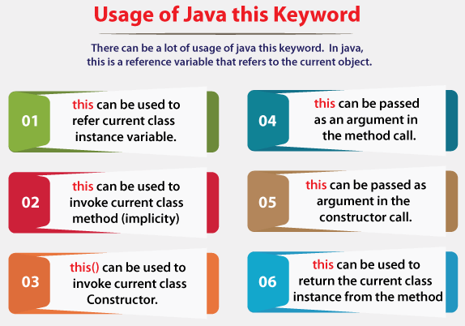

1) this: to refer current class instance variable

The this keyword can be used to refer current class instance variable. If there is ambiguity between the instance variables and parameters, this keyword resolves the problem of ambiguity.

### 2) this: to invoke current class method

You may invoke the method of the current class by using the this keyword. If you don't use the this keyword, compiler automatically adds this keyword while invoking the method. Let's see the example

### 3) this() : to invoke current class constructor

The this() constructor call can be used to invoke the current class constructor. It is used to reuse the constructor. In other words, it is used for constructor chaining.

1. **class** A{
2. A(){System.out.println("hello a");}
3. A(**int** x){
4. **this**();
5. System.out.println(x);
6. }
7. }
8. **class** TestThis5{
9. **public** **static** **void** main(String args[]){
10. A a=**new** A(10);
11. }}